🛠️ Steps to Complete the Task

1. Access Jenkins Server
Log in to the Jenkins server from the jump host to perform all required configurations.
ssh jenkins@jenkins
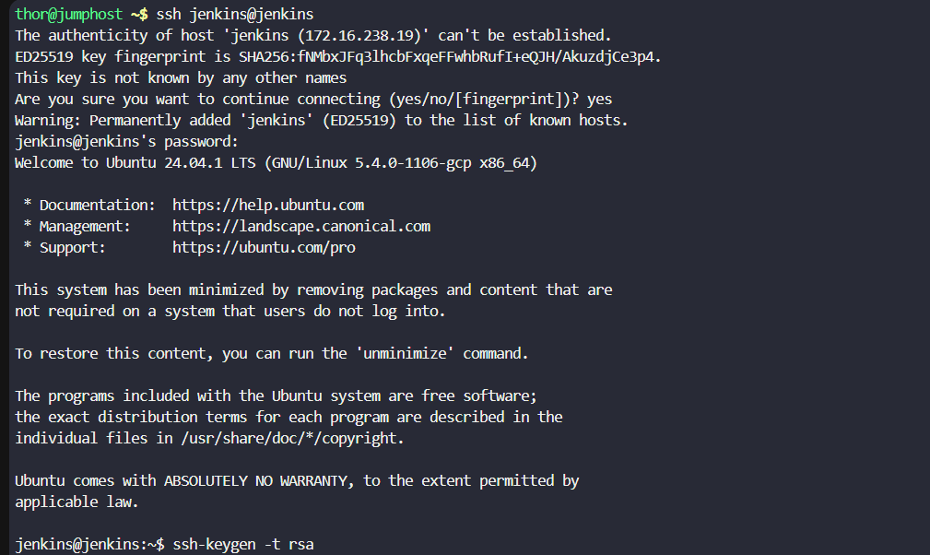
Note: This connects to the Jenkins host where the job will be created and executed.

2. Generate SSH Key for Jenkins User
Create an SSH key pair for the jenkins user to enable passwordless authentication.
ssh-keygen -t rsa
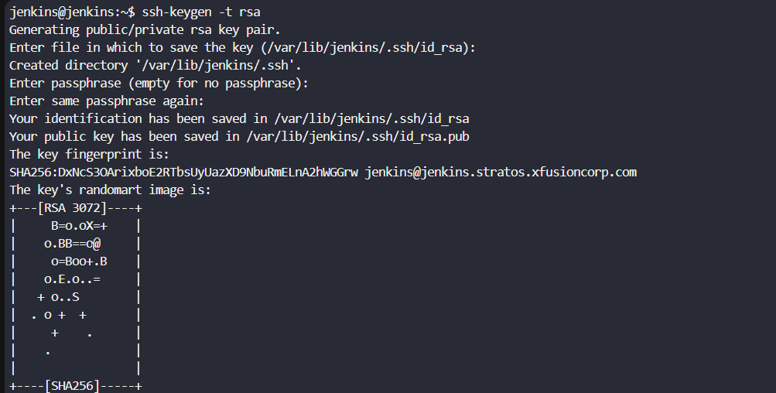
Note:
- Use default file location
- Keep passphrase empty for non-interactive Jenkins execution

3. Copy SSH Key to Application Server
Allow Jenkins to securely fetch Apache logs from the application server.
ssh-copy-id steve@stapp02
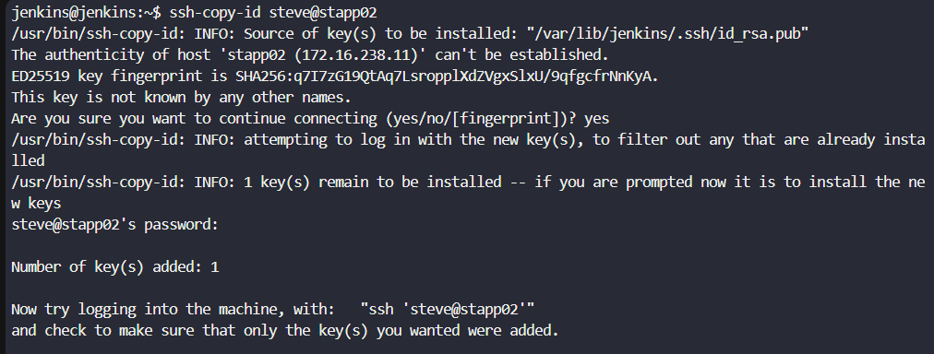
Note: Required for Jenkins to access Apache log files without prompting for a password.

4. Copy SSH Key to Storage Server
Allow Jenkins to securely transfer logs to the storage server.
ssh-copy-id natasha@ststor01
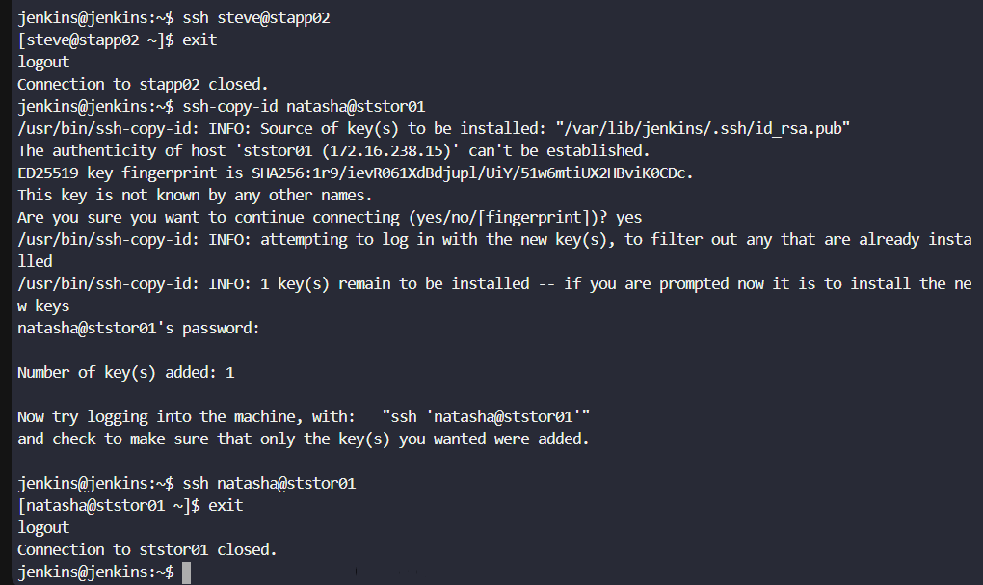
Note: This enables automated log uploads to the destination server.

5. Login to Jenkins Web UI
- Open Jenkins from the top menu
- Login with:
  - Username: admin
  - Password: Adm!n321
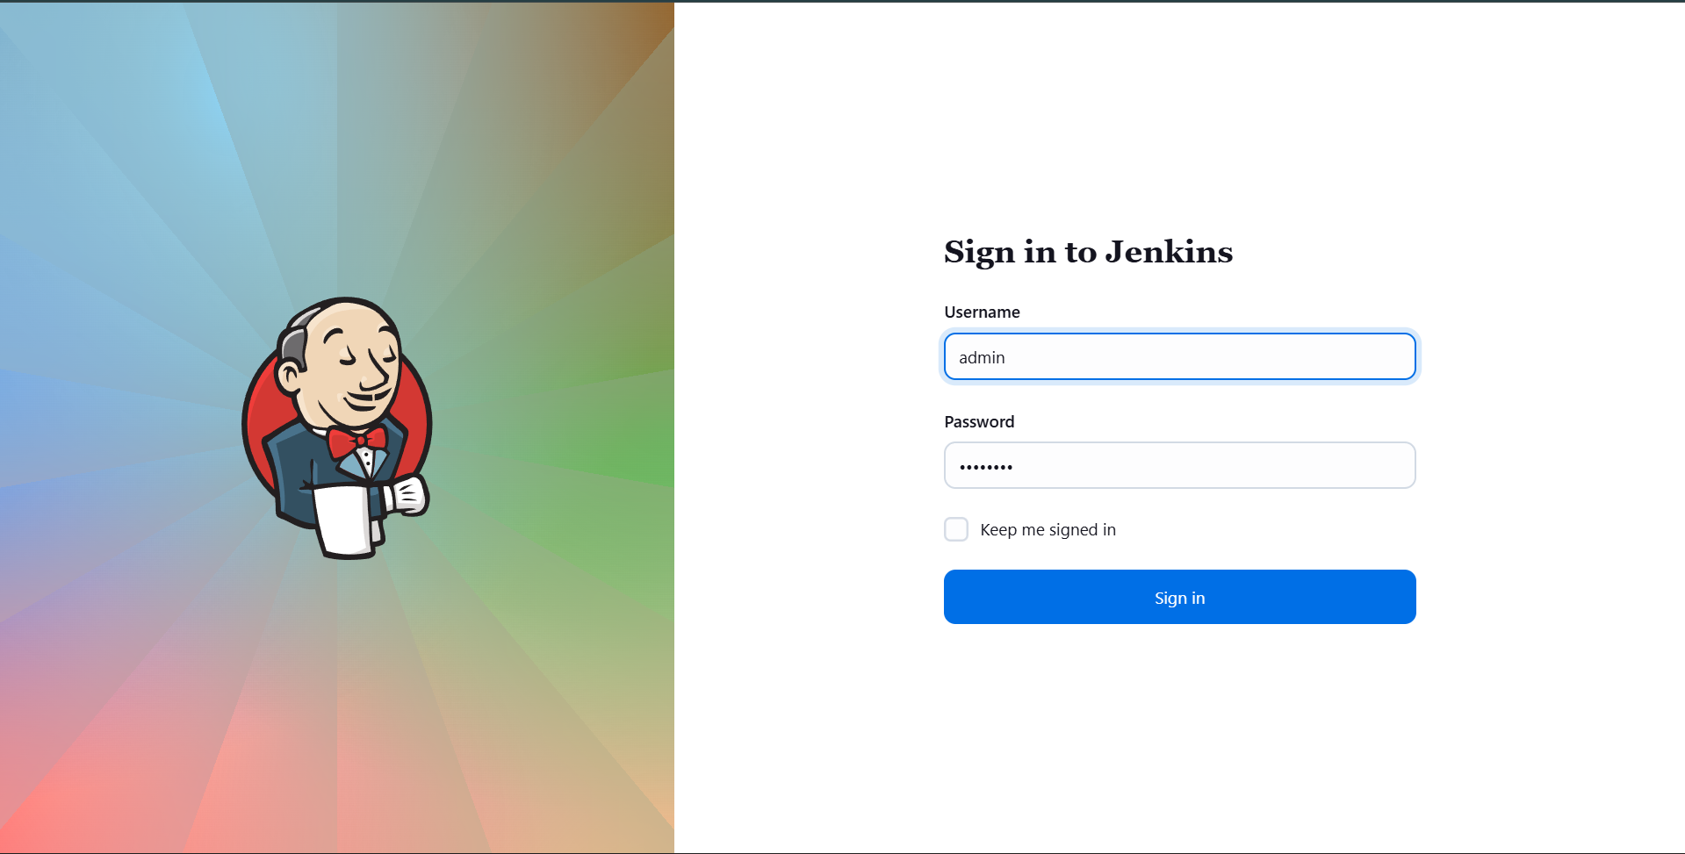
Note: Ensure Jenkins is fully loaded after any plugin installation.

6. Create a New Jenkins Job
- Click New Item
- Enter job name: copy-logs
- Select Freestyle project
- Click OK
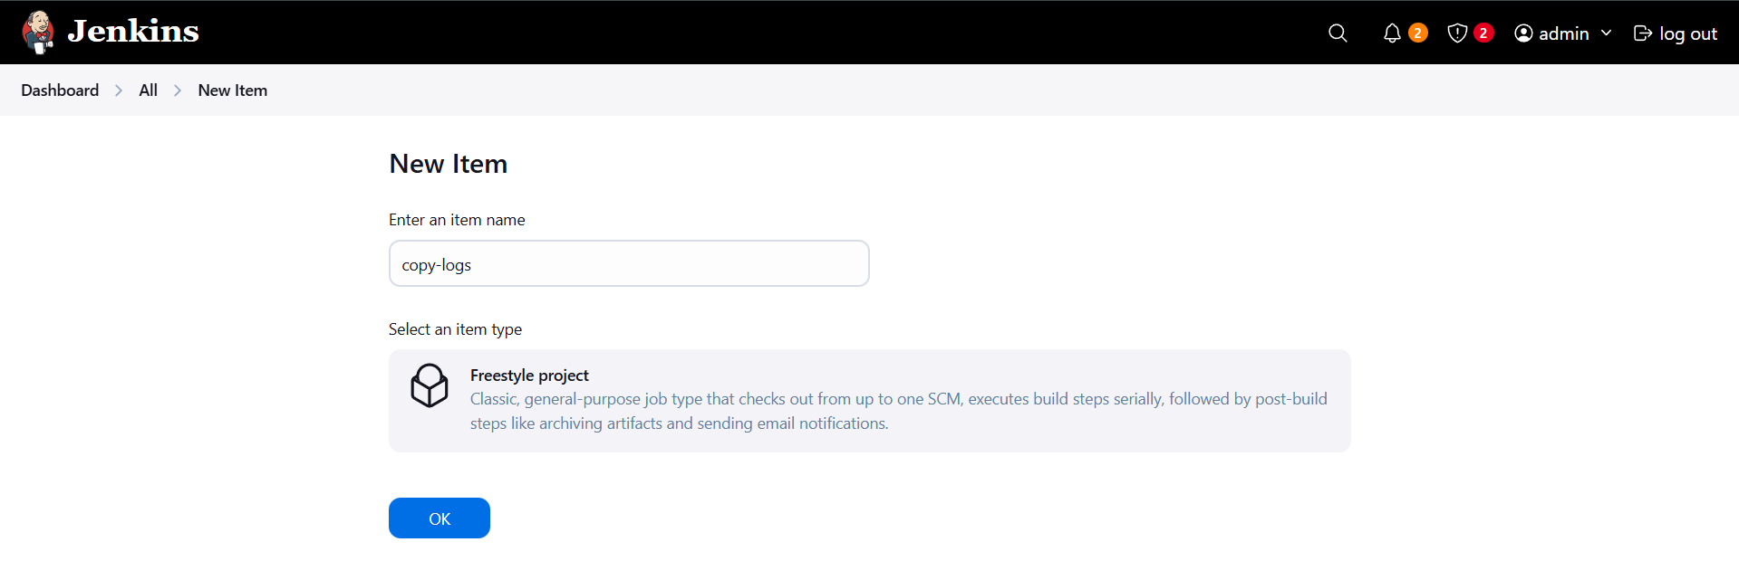
Note: Freestyle project is sufficient for simple scheduled log collection.

7. Configure Job Schedule (Cron)
Under Build Triggers:
- Enable Build periodically
- Add cron expression:
*/7 * * * *
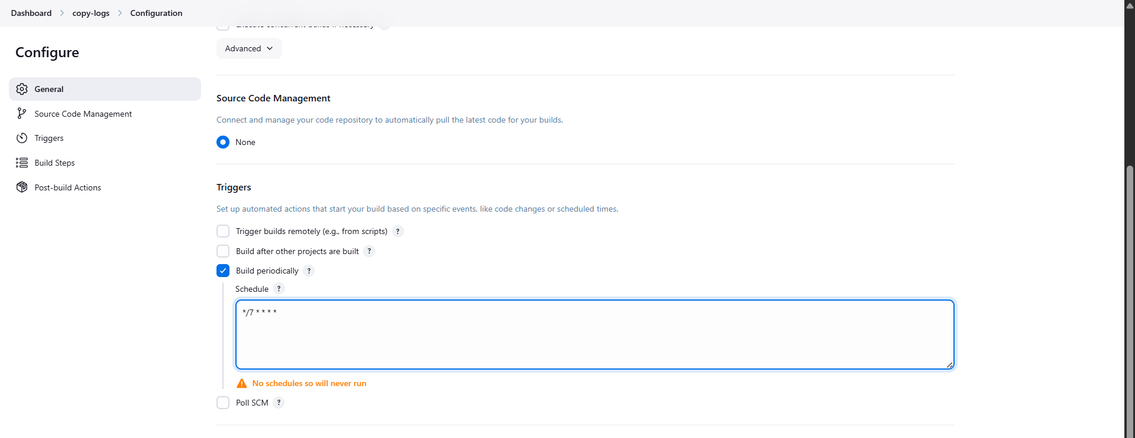
Note: This schedules the job to run every 7 minutes.

8. Configure Build Steps
Under Build → Execute shell, add the following commands:
scp steve@stapp02:/var/log/httpd/access_log .
scp steve@stapp02:/var/log/httpd/error_log .
scp access_log error_log natasha@ststor01:/usr/src/finance
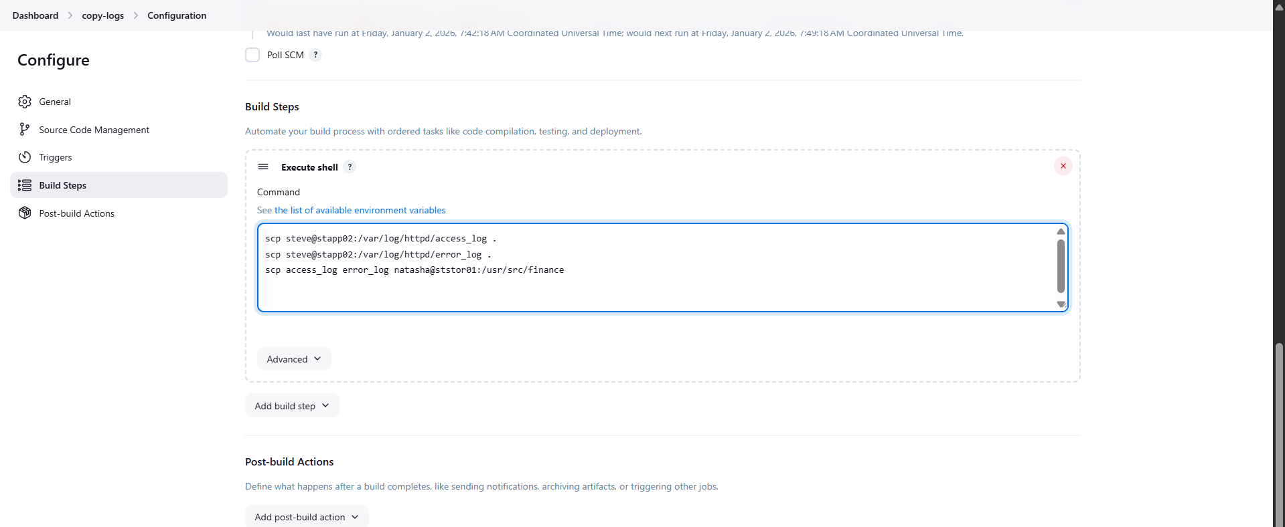
Note:
- First two commands copy Apache logs from the App Server
- Third command transfers logs to the Storage Server

9. Save and Run the Job
- Click Save
- Select Build Now
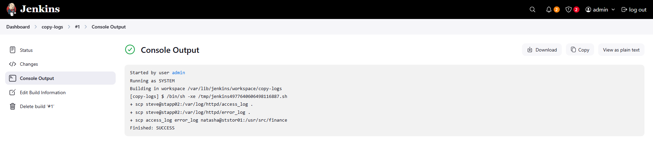
Note: Console Output should show Finished: SUCCESS.

10. Verify Logs on Storage Server
Login to the storage server and validate log availability.
ssh natasha@ststor01
ls /usr/src/devops
Expected Output:
access_log
error_log
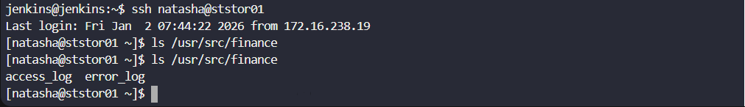
Note: Successful presence confirms end-to-end automation is working.

